Grammar Test  1/8/15  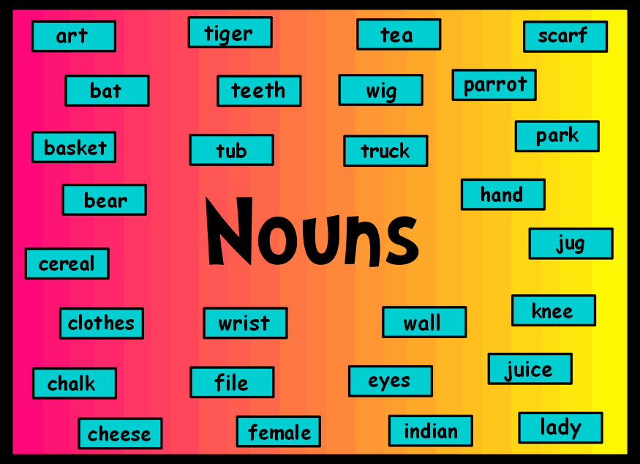 | 8th Grade  Ch 2 - Nouns  - Kinds of nouns  - Abstract  - Concrete  - Common  - Proper  - Collective  - Singular and Plural Nouns  - Possessive Nouns  - Compound Nouns  - The Jobs Nouns Do  - Direct object  - Indirect object  - Predicate noun  - Subject
7th Grade  Ch 2 – Nouns  - Kinds of nouns  - Abstract  - Concrete  - Common  - Proper  - Collective  - Singular and Plural Nouns  - Possessive Nouns  - Compound Nouns  - The Jobs Nouns Do  - Direct object  - Indirect object  - Predicate noun  - Subject  - Object of preposition | 6th Grade  Ch 2 – Nouns  - Kinds of nouns  - Common  - Proper  - Collective  - Singular and Plural Nouns  - Possessive Nouns  - Compound Nouns  - The Jobs Nouns Do  - Direct object  - Indirect object  - Predicate noun  - Subject  - Object of preposition

